Primary School Face to Face Interactions

Nicholas W. Chen

w209 HW5 Gephi Visualizations

July 12, 2017

**Visualization 1 – Differential Socialization by Grade**

This first visualization shows several interesting differential social patterns between first and fifth graders. First graders are the cluster shown in purple on the left while fifth graders are the cluster shown in orange on the right. The size of the nodes represents the degree of the node or the number of edges the node has. The first interesting insight is that the degree of almost all nodes in the first grade group is almost as high as the degree of the highest degree of any of the nodes in the fifth grade groups. This suggests that first graders are not as cliquey as fifth graders, having face to face interaction with more individuals. The second interesting insight is that the fifth graders with the most face to face interactions (the larger nodes at the top of the right hand side cluster) are those who also have face to face interactions with first graders. Fifth graders with no face to face interactions with first graders generally have fewer face to face interactions overall. One potential explanation for this is that these are children with siblings in the first grade and as a result of having siblings, these fifth graders are more social than their peers.

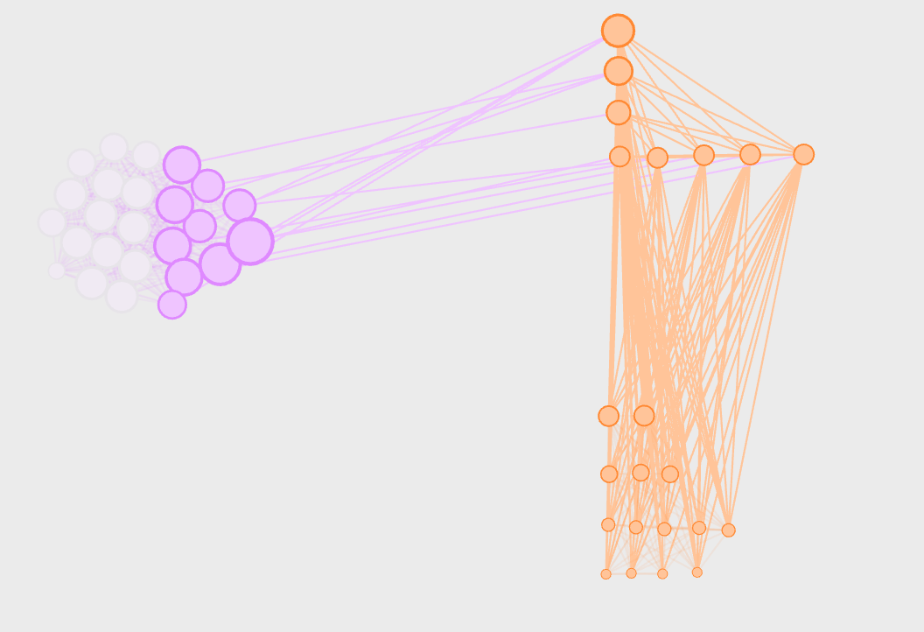

**Visualization 2 – Teacher Centrality by Grade**

This second visualization shows that the fifth grade teacher is more integrated within his or her class than the first grade teacher.

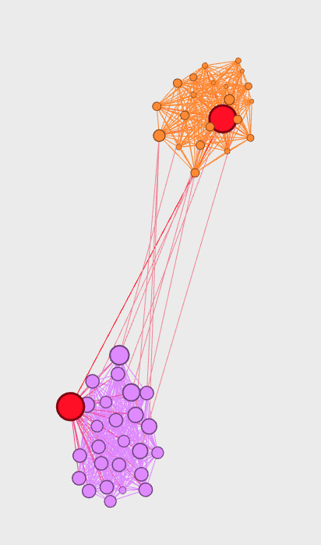

**Visualization 3 – Length of Interaction by Group**

This visualization utilizes the circular layout plugin and filters that limit the graph to display interactions that lasted longer than 30 minutes. There are a very select few interactions that last longer than 30 minutes. The black group of nodes represents teachers suggesting that one of these long interactions was a teacher working directly with a student. This could be a special needs student or a student getting extra help with their work. It would be interesting to examine the other types of interactions between students that lasted longer than 30 minutes.

